**Temperature Map**

For any plant, the climate it is around is very crucial to its life. For this reason, the temperature it observes is closely controlled and monitored. When producing mass amounts of crops in greenhouses, it’s hard to keep a constant temperature value for every crop in every corner; some areas observe warmer temperatures and some observe cooler. For this reason, we plan to create a map that shows the climate in every part of a greenhouse as a matrix to better control the growth and output of its crops.

**Motive**

The goal of our project is to observe the temperatures around a greenhouse to essentially, ensure the longevity of all plants lives. With this map, we will be able to see areas which observe temperatures within a certain healthy range, and which areas are in extreme hot or cold conditions. Consequently, temperatures in extreme conditions can be spotted easily, be regulated, and maintained within the healthy range.

**Strategy**

When planning, we decided to use a temperature that would set the ideal range for temperatures to be considered safe for crops. All the vertices are observed temperatures and the weight will be calculated by taking the magnitude of difference between the ideal and the edge. For example, our ideal temperature for this example is 25° C. With all the data values pointing out of set ideal, we then calculated the weight by taking the absolute value of distance from ideal. Doing so results in a Minimum Spanning Tree from ideal temperature locations to extreme (higher/lower) temperature locations. Figure 1 shows our initial plan.

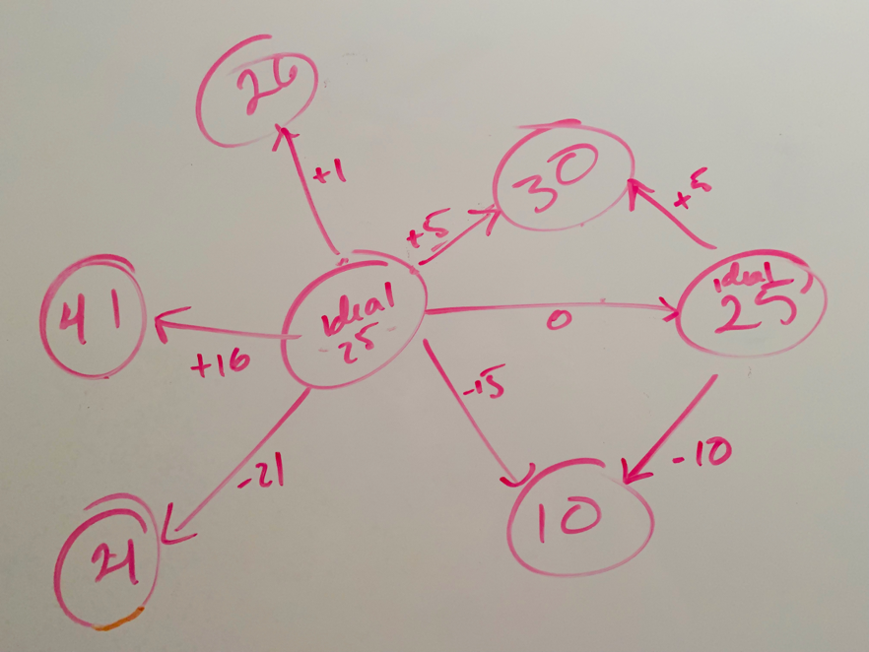

Figure 1: Strategy for Implementation

**Implementation**

Our project essentially requires us to find a minimum spanning tree in a matrix of temperatures in a specific location. Thus, we used Kruskal’s algorithm for the main design of our program. When implementing and testing, we used a randomly generated matrix of values that are lower than 40° C, representing temperatures in a specific location as shown in figure 2.

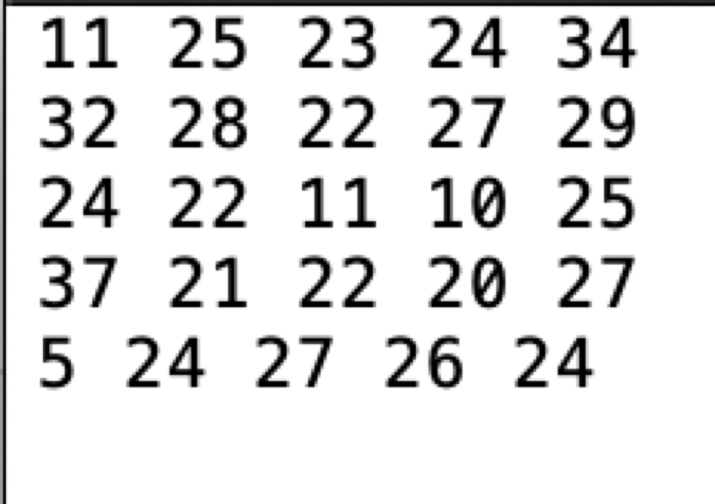

Figure 2: Sample of data values

If we set our range to 土 3° C, then we should expect a path similar to figure 3. As a result, we should be able to see a path within our range and higher/lower extremes. Figure 4 shows yellow circles as a path within 25° C 土 3° C, red circles show extreme hot temperatures and blue shows extremely cold.

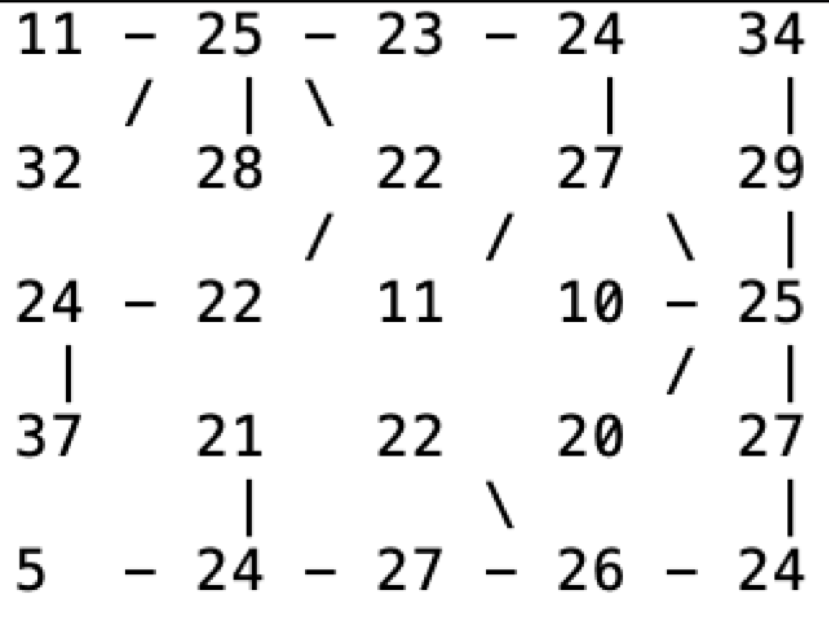

Figure 3: Kruskal’s map implemented with a range around idea temp

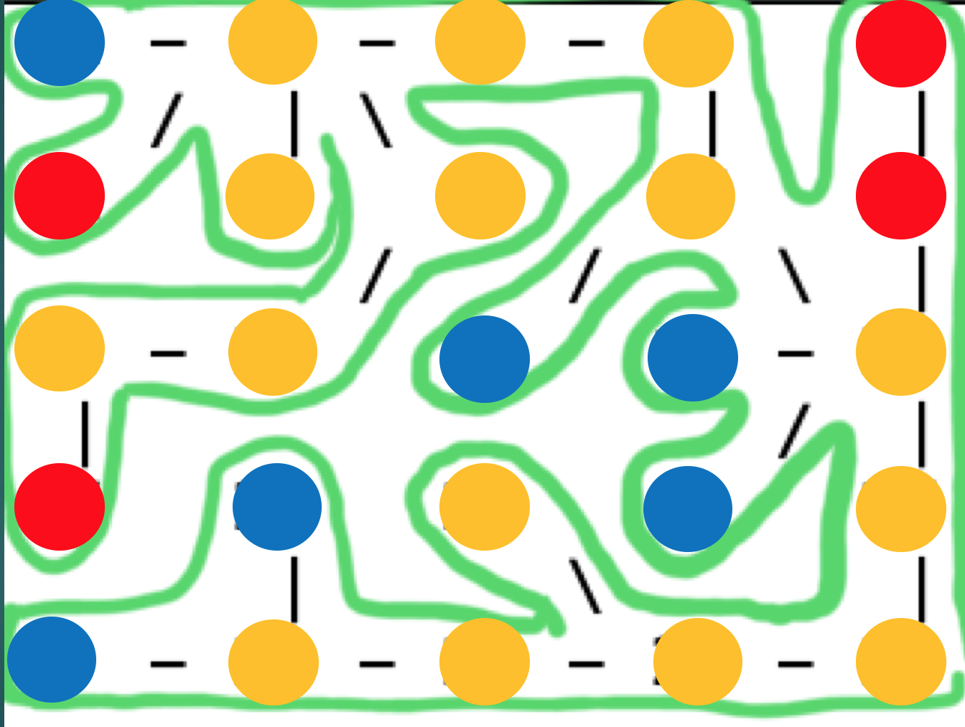

Figure 3: Kruskal’s map implemented with a range around idea temp

**Future Plans**

Our current implementation just presents a path of temperatures within a range. In the future, we would develop a GUI with our data that overlaps greenhouse floor plans. Thus, with this blueprint, results will be easy to follow. Additionally, we would incorporate and correlate similar measurements such as humidity. To take it a step further, we can also think about developing and building a robot that would go around and collect these data temperatures within the matrix of the greenhouse and automatically display a path on the greenhouse map showing ideal results when connected to a computer.